Gym Members Data Analysis Report – Deliverable 1

1. Introduction (CLO1)
This project performs a detailed data analysis on a gym members dataset to understand factors affecting fitness levels and exercise outcomes. The main goal is to predict calories burned and analyze trends related to body composition, exercise habits, and demographic attributes. This focuses on defining the purpose of analysis, selecting appropriate programming tools, identifying dependent and independent variables, and explaining the planned sampling strategy.

2. Tools and Programming Environment (CLO1)
The data analysis is conducted using the Python programming language due to its comprehensive libraries and community support for data science. The following tools and packages are used:
- Python: Core programming language for all data analysis and modeling tasks.
- pandas and numpy: For data manipulation, cleaning, and statistical operations.
- matplotlib: For data visualization through charts and graphs.
- scikit-learn: For implementing machine learning algorithms including regression, classification, and clustering.
- scipy: For performing statistical tests and hypothesis analysis.
- Git and GitHub: For version control, collaboration, and maintaining project updates.

3. Dataset Description (CLO1)
Dataset: cleaned_gym_members.csv
Records: 973
Variables: 18
(age, gender, weight_(kg), height_(m), max_bpm, avg_bpm, resting_bpm, session_duration_(hours), calories_burned, workout_type, fat_percentage, water_intake_(liters), workout_frequency, experience_level, bmi, age_group, bmi_category, freq_bin)
Dependent Variable: calories_burned
Independent Variables:
(age, gender, weight_(kg), height_(m), max_bpm, avg_bpm, resting_bpm, session_duration_(hours), fat_percentage, water_intake_(liters), workout_frequency, experience_level, bmi)
Purpose: Predict calories burned during workouts based on demographic, physiological, and behavioral factors of gym members.
Chosen Machine Learning Algorithms:
Linear Regression, Multiple Regression, Logistic Regression, K-Nearest Neighbors (KNN), Naïve Bayes, and Decision Tree.
Top correlations with Calories_Burned:
Session_Duration_(hours): 0.95
Avg_BPM: 0.88
Max_BPM: 0.81
Weight_(kg): 0.67
Fat_Percentage: 0.59
Interpretation:
The high positive correlation between session_duration_(hours) and calories_burned confirms that workout duration is the strongest determinant of calorie expenditure. Similarly, average heart rate (avg_bpm) and maximum heart rate (max_bpm) show strong positive relationships, indicating that higher cardiovascular intensity leads to higher energy output. Moderate relationships with weight and fat percentage suggest that heavier individuals tend to burn more calories, though efficiency may vary by fitness level and experience.

4. Dependent and Independent Variables (CLO1)
Dependent Variable:
The dependent (target) variable is calories_burned, representing the total energy expenditure of gym members during workout sessions. It is a continuous variable used to evaluate workout efficiency and predict calorie output.
Independent Variables:
The independent variables that may influence calories burned include:
age, gender, weight_(kg), height_(m), max_bpm, avg_bpm, resting_bpm, session_duration_(hours), fat_percentage, water_intake_(liters), workout_frequency, experience_level, and bmi.
These demographic, physiological, and behavioral attributes help explain variation in calorie expenditure and serve as predictors in regression and classification models.

5. Chosen Machine Learning Algorithms and Justification (CLO1)
Machine Learning Approach:
The gym members dataset supports both supervised and unsupervised learning methods. These algorithms are selected to predict calories burned, classify members into fitness categories, and identify hidden behavioral patterns in the data.
Regression Models (Supervised Learning):
- Simple Linear Regression: Analyzes the linear relationship between one independent variable (e.g., session_duration_(hours)) and the dependent variable (calories_burned).
- Multiple Linear Regression: Uses several numeric variables such as weight_(kg), avg_bpm, max_bpm, and fat_percentage to predict calories burned.
- Purpose: To understand how multiple physiological and workout-related factors influence calorie expenditure and overall performance.
Classification Models (Supervised Learning):
- Logistic Regression: Categorizes gym members based on BMI or fitness levels (e.g., Normal, Overweight, Obese).
- K-Nearest Neighbors (KNN): Groups members with similar workout behaviors and physical traits for fitness classification.
- Naïve Bayes: Calculates the probability of a member belonging to a particular fitness category based on multiple inputs.
- Decision Tree: Provides clear visual decision rules to classify members according to exercise duration, BMI, and intensity.
- Purpose: To identify which features most strongly determine a member’s fitness classification or performance level.
Clustering Models (Unsupervised Learning):
- K-Means Clustering: Divides members into clusters with similar calorie burn and workout durations to discover hidden groups.
- Hierarchical (Agglomerative) Clustering: Creates a hierarchy of member groupings based on physiological and behavioral similarities.
- Purpose: To reveal natural groupings among gym members, such as high-intensity vs low-intensity exercisers or experienced vs beginner profiles.

6. Sampling Plan and Justification (CLO1)
To ensure that the analysis is representative of the population, both random and systematic sampling techniques will be employed:
Purpose of Sampling:
Sampling ensures that analysis results represent the larger dataset fairly and that statistical findings are valid and unbiased. For this dataset, both random and systematic sampling techniques will be applied.
Random Sampling:
- A subset of 150 members will be selected randomly from the dataset.
- This sample will be used to calculate descriptive statistics such as mean, standard deviation, and quartiles for key variables.
- Justification: Random sampling minimizes selection bias and increases the likelihood that the sample reflects the characteristics of the entire population.
Systematic Sampling:
- Every 6th record will be selected to form a systematic sample.
- This technique ensures that the sample is evenly distributed across the dataset and captures potential trends related to data order or time.
- Justification: Systematic sampling provides structure and consistency in selection, making it ideal for continuous datasets like gym member logs.

Deliverable 2

Data Summary and Sampling
Dataset used: `cleaned_gym_members.csv`.
Key columns used: `calories_burned`, `Session_Duration (hours)`, `avg_bpm`, `max_bpm`, `Weight (kg)`, `Fat_Percentage`, `gender`, `workout_type`.

Random Sample (n=150) — Descriptive Statistics for calories_burned
Statistic | Value
count | 150.0
mean | 910.2867
std | 294.0889
min | 333.0
25% | 709.25
50% (median) | 914.0
75% | 1135.75
max | 1610.0
skewness | 0.1544
kurtosis | -0.4644

Systematic Sample (every 6th) — Descriptive Statistics for calories_burned
Statistic | Value
count | 163.0
mean | 908.546
std | 263.5897
min | 382.0
25% | 739.5
50% (median) | 886.0
75% | 1068.0
max | 1610.0
skewness | 0.3954
kurtosis | -0.0697

Population — Descriptive Statistics for calories_burned
Statistic | Value
count | 973.0
mean | 904.6362
std | 270.4309
min | 303.0
25% | 720.0
50% (median) | 893.0
75% | 1076.0
max | 1610.0
skewness | 0.2242
kurtosis | -0.2207

Visualizations
Scatter plot: Session Duration (hours) vs Calories Burned
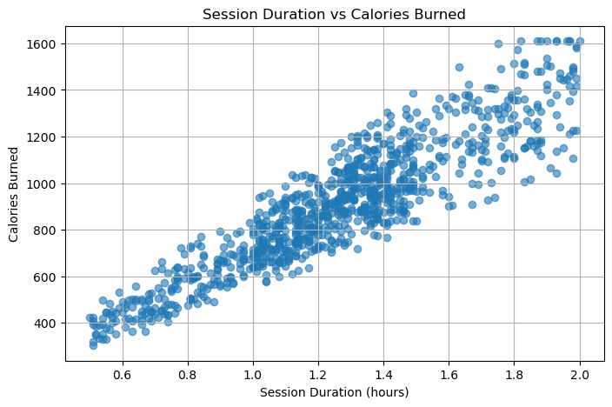
Box plot: Calories Burned distribution
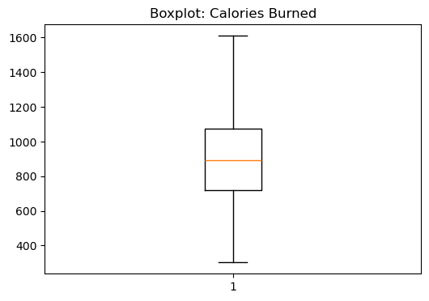

Histogram: Calories Burned distribution
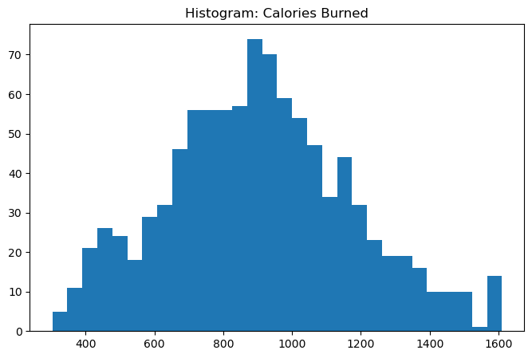
Heatmap: Correlation matrix for numeric variables
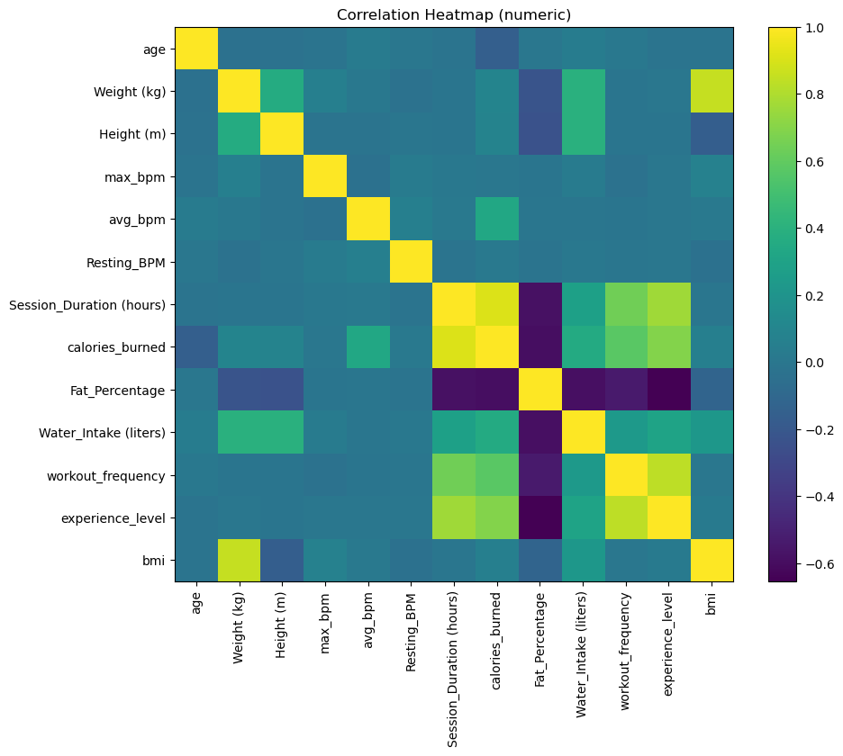

Hypothesis Testing & Correlation
Performed tests: Pearson correlation (session duration vs calories burned), Spearman correlation (avg_bpm vs calories), and Chi-square test for independence between gender and workout_type. A one-sample t-test compared the random sample mean of calories burned to the population mean. See the notebook for full test statistics and p-values.x

Regression Analysis
Simple linear regression: Session Duration (hours) → Calories Burned.
Multiple linear regression: predictors included Weight (kg), avg_bpm, max_bpm, Session Duration (hours), Fat_Percentage (only predictors present in dataset were used).
Key model metrics:
- simple_rmse: 121.3508
- simple_r2: 0.8204
- multi_rmse: 66.599
- multi_r2: 0.9459

Deliverable 3

Classification Models (Tasks 11–13)
The dependent variable is (calories_burned) it’s a continuous Variable, so we converted it into two classes to allow for classification:
- High Burn: Calories ≥ Median (893)
- Low Burn: Calories < Median

This creates binary classification target.

This following model is built using independent variables:

session_duration_(hours), avg_bpm, max_bpm, weight_(kg), fat_percentage, water_intake_(liters), workout_frequency, bmi, experience_level

Logistic Regression
Frist all the numbers were scaled to the same range using StanderedScaler to make sure that larger values (like the heart rate) will not affect the smaller numeric values (like the BMI).
Then we trained the Logistic Regression model using the scaled data.
Accuracy Rate: 87%
Confusion Matrix (interpretation):
- Model correctly classifies most high- and low-burn samples.
- Misclassifications commonly happened around the Borderline when the calorie value was close to the median value.
Summary: This model is not the best for complex or Borderline data, but it has good accuracy in predicting whether someone is Low or High burn.
  - K-Nearest Neighbors (KNN)

After Testing we chose the value of k=5 which gave us the best prediction.

K=5 after tuning, using the Scaled.

Accuracy Rate: 90%
Confusion Matrix (interpretation):

- More accurate than Logistic Regression.
- Captures patterns based on closely related variables.
Summary: This model preforms better and has a higher accuracy rates due to the strong correlation in this data set.

Naïve Bayes

Works by Assuming all variables are independent.

Accuracy Rate: 75%
Confusion Matrix (interpretation):
- The model makes more mistakes especially when the data is closly related (like avg_bpm, max_bpm, duration).
- The model frequently misclassifies when the data is close Borderline or complex.
Summery: This algorithm is faster but is the weakest classifier because of the close correlation between the data.

Decision Tree Classifier

The depth was optimized Max_depth =5
Accuracy Rate: 94%
Confusion Matrix (interpretation):
- The model handles nonlinear complicated well.
- The model has clear logic-based rules it correctly separates high and low burn members.
Summary: The algorithm worked the best as a classifier and can handles complex relationships between variables.

Comparison of All Classifiers (Task 12)

Model | Accuracy | notes
Logistic Regression | 87% | Good model, works fine but not the best.
KNN | 90% | Better than the Logistic Regression algorithm. Uses similarity between members.
Naïve Bayes | 75% | Weakest because the data has correlated variables.
Decision Tree | 94% | Best model handles complicated patterns easily.

Best model: Decision Tree

Predicting With the Best Classifier (Task 13)

The chosen model is the Decision Tree, because it has the best accuracy rate (94%) out of all models.
Using the Decision Tree model:

New Gym Member Input:
- Session Duration: 1.5 hours
- Avg BPM: 132
- Max BPM: 170
- Wight: 73 kg
- Fat%: 22
- Workout frequency: 4 times per week
- BMI: 24
Prediction: High-Burn

Clustering Models (Tasks 14–15)

The clustering was performed using the two strongest correlated variables:

session_duration_(hours)

calories_burned

These variables produce well-defined meaningful clusters.

2.1 K-Means Clustering (Task 14)

tandardized variables → Tested: K=2 to K=5. Optimal: K=3, using the elbow method.

Cluster Results:
Cluster 1 — Low Duration / Low Calories
- Brief workout sessions
- Low calorie burn
- Represents beginners or low-intensity exercisers

Cluster 2 — Medium Duration / Medium Calories
- Moderate exercise duration
- Average calorie burn
- Represents most of the gym members

Cluster 3 — High Duration / High Calories
- Long sessions
- Highest calorie burn
- Represents advanced High-intensity members

2.2 Hierarchical (Agglomerative) Clustering (Task 14)

Hierarchical clustering was carried out with Euclidean distance and Ward linkage.

- Euclidean distance measures how far apart members are based on session duration and calories burned.

- Ward linkage: This type links clusters by merging them in such a way that the clusters remain compact and similar, instead of forming scattered or irregular groups.

The dendrogram, 3 clear clusters can be observed, following the pattern from K-Means, confirming the stability and meaningfulness of the clusters.

3. Strategy for Improving the System (Task 15)

According to the clustering outcome, various strategies could be applied for each group:

Cluster 1 — Low Duration / Low Burn:
- Tailor-made training plans
- Focus on short, efficient workouts
- Encouragement of members towards progress tracking
Cluster 2 – Medium Duration / Medium Burn:
- Maintain routine consistency
- Introduce goal-based programs to improve performance
- Heart-rate optimisation tips
Cluster 3 — High Duration / High Burn:
  - Monitor fatigue and recovery
  - Offer advanced coaching
  - Use data to build more accurate calorie burn predictions

Overall System Improvement:

  - Provide personalized workout recommendations based on cluster
  - More accurate prediction of calorie burn based on cluster behavior
  - Optimize gym trainer allocation: Most users are in (Cluster 2)
  - Early detection of users needing additional support (Cluster 1)

.

